Project Documentation

Project Title: AI BlogNest API
Team ID: [SWTID-2026-2456]
Team Leader:
[NIHARIKAA K & 24csniharikaa.k063@gmail.com]
Team Members:
[NIVEDHA L & 24csnivedha64@gmail.com]
[NAVANEETHA Y & 24csnavaneethay61@gmail.com]
[NETHRA R & 24csnethrar062@gmail.com]
[NIVEDITHA R & 24csniveditha065@gmail.com]

- Introduction

- The ContentGen backend is a powerful, secure, and intelligent REST API platform designed to simplify blog creation, content management, and AI-assisted writing.

- Built with Node.js and Express.js, the application uses MongoDB as its primary database with Mongoose ODM for efficient data modeling, validation, and seamless database interactions.

- The platform integrates Google Gemini AI to provide intelligent features such as AI-powered blog content generation, AI FAQ assistance, AI WeatherWise insights, and AI FitTrack recommendations, enabling users to create high-quality, context-aware content with minimal effort.

- Security is a core aspect of the architecture, implementing JWT (JSON Web Tokens) for stateless authentication, role-based access control (Admin, Editor, Author, Reader) for authorization, and bcrypt.js for secure password hashing.

- The backend also supports comprehensive blog management, categories and tags, comment management, media metadata handling, advanced search capabilities, and centralized error handling.

- Additional security mechanisms such as request validation, input sanitization, rate limiting, and structured logging ensure the platform remains reliable, scalable, and resilient against common web vulnerabilities.

- Designed with a modular and scalable architecture, ContentGen serves as a modern AI-powered Content Management System (CMS) that combines traditional blogging capabilities with Generative AI to deliver a smarter, faster, and more personalized content creation experience.

Scenario-Based Case Study
Background
It is a content creator who manages multiple blogs but struggles to organize posts, schedule publications, manage categories/tags, and track reader engagement efficiently.
Problem
- Difficulty managing multiple drafts, categories, and tags.
- Limited visibility into post performance and engagement analytics.
- Time-consuming processes for content approval and comment moderation.
- No streamlined system for handling media uploads or metadata.
- Lack of collaborative permission tiers for editors, authors, and administrators.
Solution
- The BlogNest backend delivers a centralized, secure API wrapper that decouples application business logic from frontend delivery ssystems.
- It introduces an internal permission matrix controlling specialized services for content scheduling, category taxonomy, media path registration, and granular user roles.
Usage
- Author Usage: Creates blog posts, uploads media pathways, organizes content drafts, and reviews their distinct post-performance data.
- Editor/Admin Usage: Accesses protected endpoints to review content queues, change publishing statuses, moderate visitor comments, and orchestrate user privilege upgrades.
- Reader Usage: Queries public list routes to consume posts and invokes comment creation endpoints.
Outcome
- By offloading workflow controls to a robust backend, content execution delays are minimized.
- Data structural integrity is strictly maintained through schema validation, security filters guarantee that only authorized roles perform administrative shifts, and persistent tracking provides raw analytics to measure post optimization metrics accurately.
2. Project Overview
Purpose:
ContentGen is a modern AI-powered Content Management System that combines traditional blogging capabilities with Generative AI for smarter, faster, and personalized content creation.

Features:

- Role-Based Route Guarding: Strict token processing blocks unauthorized tiers from modifying core settings.

- CRUD Blog Execution Engine: Complete schema management over content definitions, status states, and asset assignment paths.

- Categorization System: Native tag indices facilitate filtering and querying for enhanced discoverability.

- Comment Moderation Logic: Protected entry points for updating moderation flags (approved, pending, spam).

- Sanitization Safeguards: Payload parameter sanitation prevents XSS vectors and NoSQL parameter manipulation injections.

- AI-Driven Blog Generation Pipeline: Integrates external Large Language Model (LLM) abstractions and context-aware prompt templates to synthesize full-length, structured blog posts.

- Intelligent Content Summarization Engine: Generates concise abstracts and automated metadata summaries from extensive article content.
3. Architecture
The BlogNest application exposes structured endpoints handled by a layered server architecture model. Incoming requests undergo filter processing before interacting with data services.
Components Definition
- Interface: API tools like Postman query distinct route paths to extract JSON entities.

- Express Server Gateway: Monitors network ports, maps HTTP methods (GET, POST, PUT, DELETE), parses JSON payloads, and handles CORS headers.

- Authentication & Role Matrix Middleware: Extracts tokens from headers, validates user context signatures, and evaluates authorization for guarded resource paths.

- Granular Services (Logic Modules): Enforces isolated domain rules for blog lifecycles (Draft, Pending Approval, Scheduled, Published), comment queues, and system reporting indicators.

- Database Interface Layer: Mongoose translates operational application logic into native MongoDB queries.

- AI Flow (Service Integration): Provides automated blog post generation and real-time content summarization through specialized AI endpoints.

- BlogGenerator with AI: A specialized service that automates the generation of blog content and integrates with the AI Flow service.
Entity-Relationship (ER) Diagram Description
The underlying document structure manages several collections bound by logical application references.
User Entity
- _id (Primary Key - ObjectId)

- name (String, Required)

- email (String, Required, Unique)

- password (String, Hashed, Required)

- role (String, Default: "reader")

Post Entity
- _id (Primary Key - ObjectId)

- userID (Foreign Key referencing User Collection)

- name (String, Required - represents Title)

- photo (Object/String pathway link)

- message (String - Core content body)

- likes (Number, Default: 0)

- timestamps (True)

Key Structural Mappings
- User to Post (One-to-Many): An author can submit multiple blog documents.

- User to Comment (One-to-Many): Readers/Users can append multiple response comments across independent post nodes.

- Post to Comment (One-to-Many): A single blog document stores individual referenced comment submissions.

4. Setup Instructions
Prerequisites:
- Operating System: Windows 10/11, macOS, or Linux.

- Node.js (v16 or above).

- npm (v8 or above).

- Express.js.

- MongoDB.

- Postman.

- Visual Studio Code or similar code editor.

Installation Steps:
- Create a new project folder.

- Open the project folder in Visual Studio Code.

- Create a Server folder and open it in the VS Code terminal.

- Initialize the project using: npm init -y.

- Create server.js.

- Create folders: models, controllers, and routes.

5. Folder Structure
Project/
|-- Server/
| |-- server.js
| |-- models/
| |-- controllers/
| |-- routes/
|-- App.js

6. Running the Application
Server setup:
Open the Server folder in the VS Code terminal and run npm init -y.
Create server.js and configure the required server components.

Database Configuration:
Install Mongoose using: npm install mongoose.
Create the database connection and define schemas and models before performing backend actions.

API Execution:
Install Postman or ThunderClient and start the backend server using: npm start.

7. API Documentation
AI Blog Generation:
/api/ai/generate-blog

AI Blog Summarization:
/api/ai/summarize
The source document also includes API testing sections for User Registration, User Login, Create Blogs, Fetch Blogs, Generate AI Blogs, and Summarize Blogs.

8. Authentication

- JWT (JSON Web Tokens) are used for stateless authentication.

- bcrypt.js is used for secure password hashing.

- Role-based access control is implemented for Admin, Editor, Author, and Reader roles.

- Authentication middleware extracts and validates tokens and checks authorization thresholds for protected resources.

Roles and Responsibilities

- Admin: Complete environment override control. Can manage user registrations, alter role assignments, prune malicious comments, and inspect logging entries.

- Editor: Focuses on editorial workflows, reviews pending draft posts, marks records for publication, and handles category cleanup.

- Author: Can create posts bound to their explicit account record.

- Reader: Reads published materials and posts comments under an authenticated identity.

9. User Interface

- In this pure headless backend service context, standard user-interface template views do not exist.

- The interface layer functions as an API Routing Layer.

- It links network requests on specified paths directly to their associated controller handler logic.

- API tools such as Postman are used to query route paths and extract JSON entities.

10. Testing

- Install Postman or ThunderClient for API testing.

- Start the backend server using npm start.

- Test User Registration, User Login, Create Blogs, Fetch Blogs, Generate AI Blogs, and Summarize Blogs.

- API responses are checked through the backend REST endpoints.

11. Screenshots

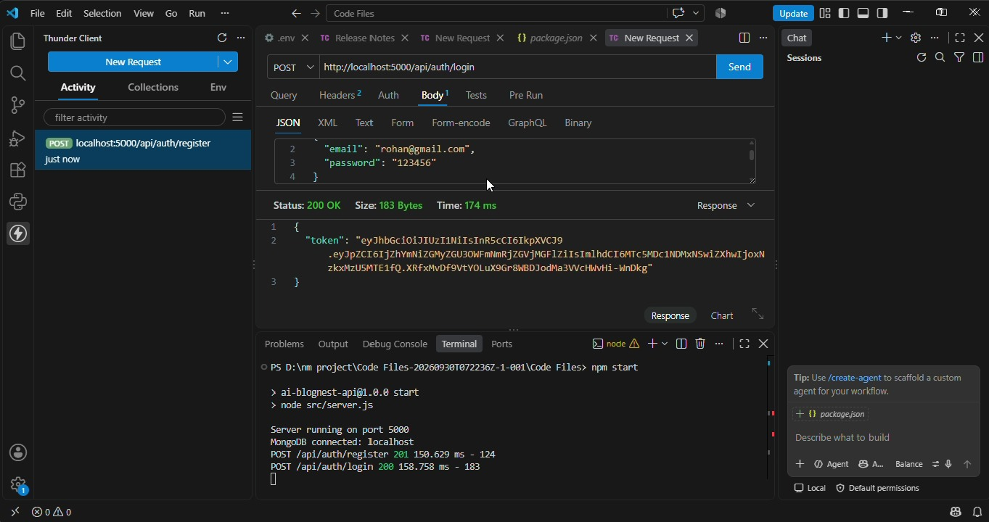

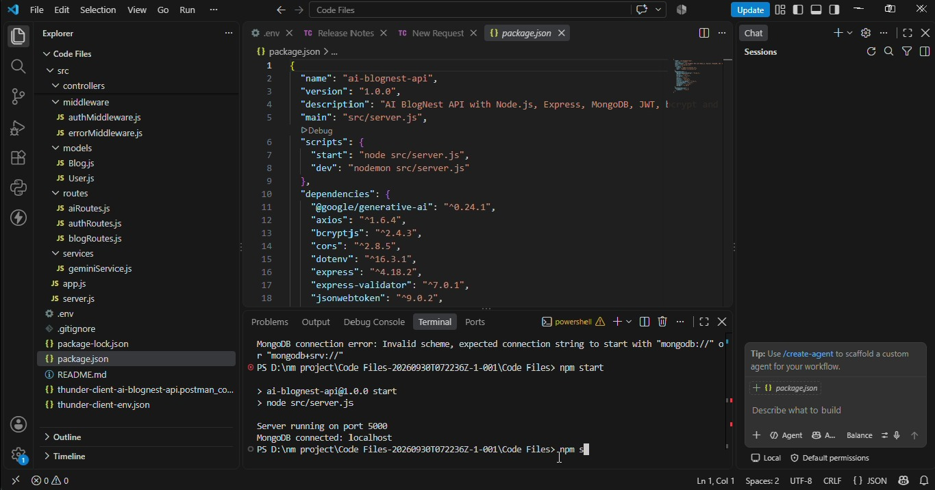

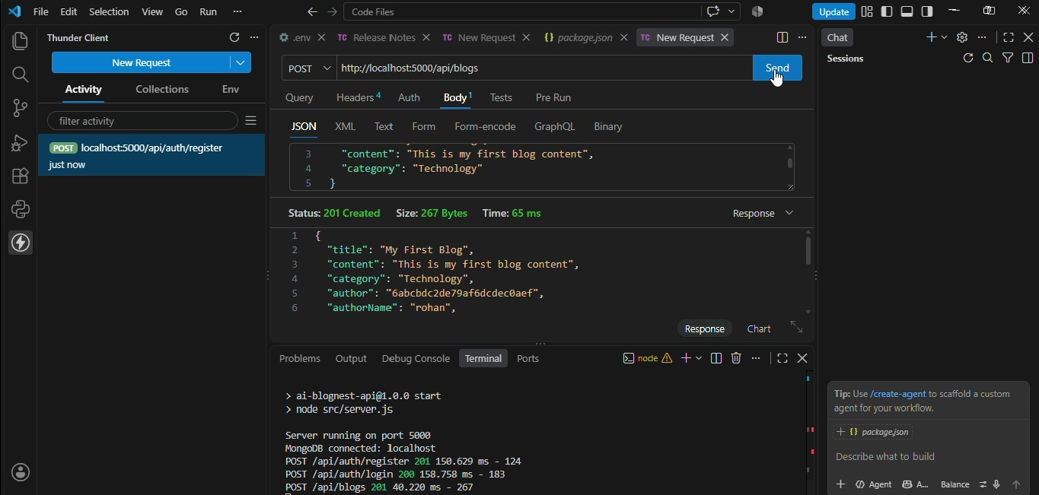

12. Known Issues
- AI-generated blog content depends on the availability of the Google Gemini AI service.

- External AI services and API configurations are required for full AI-powered content generation and summarization.

- Internet connectivity is required for accessing external AI services and API endpoints.

- API performance may be affected when external AI or database services are unavailable.

- Dependence on external AI services may affect the availability of AI-generated content and summaries.

- Large blog content and frequent API requests may require additional processing and server resources.

13. Future Enhancements
- Mobile application support for accessing blog content and management features on smartphones.

- Enhanced AI-powered blog content generation with more personalized and context-aware content.

- Integration with additional AI services for improved content generation and summarization.

- Advanced analytics and reporting features to track blog performance and reader engagement.

- Enhanced search, categorization, and tagging features for better content discovery.

- Support for additional collaboration features for Admins, Editors, Authors, and Readers.
Demo Video Link: https://drive.google.com/file/d/1_NQLE3ObWtZCRjJ1DtDeoC_6SJiWfiVS/view?usp=sharing

